Town of Shandaken
County of Ulster
State of New York

The Town of Shandaken Town Board conducted a Regular Monthly Meeting on Monday September 14, 2020. Shandaken Town Hall. 7209 Rt. 28 Shandaken, NY- 7pm

Call to Order
Pledge of Allegiance
Roll Call

Members Present Robert A. Stanley – Supervisor
Kyle R. Steen - Board Member
Peter DiSclafani – Board Member
Kevin VanBlarcum – Board Member
Faye Storms – Board Member

Recording Secretary Joyce Grant - Town Clerk

On a Stanley/Storms motion the Town Board unanimously approved the minutes of the previous meeting as submitted by the Town Clerk.

Town of Shandaken Town Board
Regular Monthly Meeting Agenda
Monday, September 14, 2020

- Call to Order
- Pledge of Allegiance
- Roll Call
- Approval of previous T/B Meeting minutes
- Supervisor’s Financial Report
- Communications –
  - Climate Smart Resiliency – UC Cornell Coop Ext. – Melinda Herzog & Brent Gotsch
  - Aaron Bennett – Little League Baseball for Fall
- Committee Reports:
  - Ambulance
  - Building/Zoning
  - Police
  - Phoenicia Water
  - Pine Hill Water
  - Museum
  - Recreation
  - Shandaken Septic
- Public Comments on Resolutions
- Motions:
- Resolutions:
      - Pay All Bills
      - Parks and Recreation – Accept Bids for Park Benches
        - 10 – 8 foot All-Weather Picnic Tables for various parks
      - Town Board – Appoint Police Reform Collaborative
        - Kevin Van Blarcum (Town Board), Chad Storey (Town Police Chief), W. James McGrath (Town Police Commission), Wendy Lockwood (Town Court Clerk), Crystal Wei (Mt. Tremper), Michelle Spark (Mt. Tremper), Elizabeth Potter (Phoenicia), Syed Shahzad Adil Shah, (Phoenicia), Charles Perez (Big Indian), Joshua Brown (Pine Hill), Manuela Jean-Pierre (Pine Hill)
      - Town Board – Authorize Contract with Engineer for Planning Board
        - Milone & MacBroom, SEQR Reviews
      - Town Board – No Campaign Signs prior to Columbus Day
        - Monday, October 12, 2020
      - Highway – Purchase Vehicle – Firetruck for Culverts

- Open Public Comment
- Meeting Adjournment - IN MEMORY OF:
Virgil “Stubby” Curtis, Jr. Jeffrey Jacobson

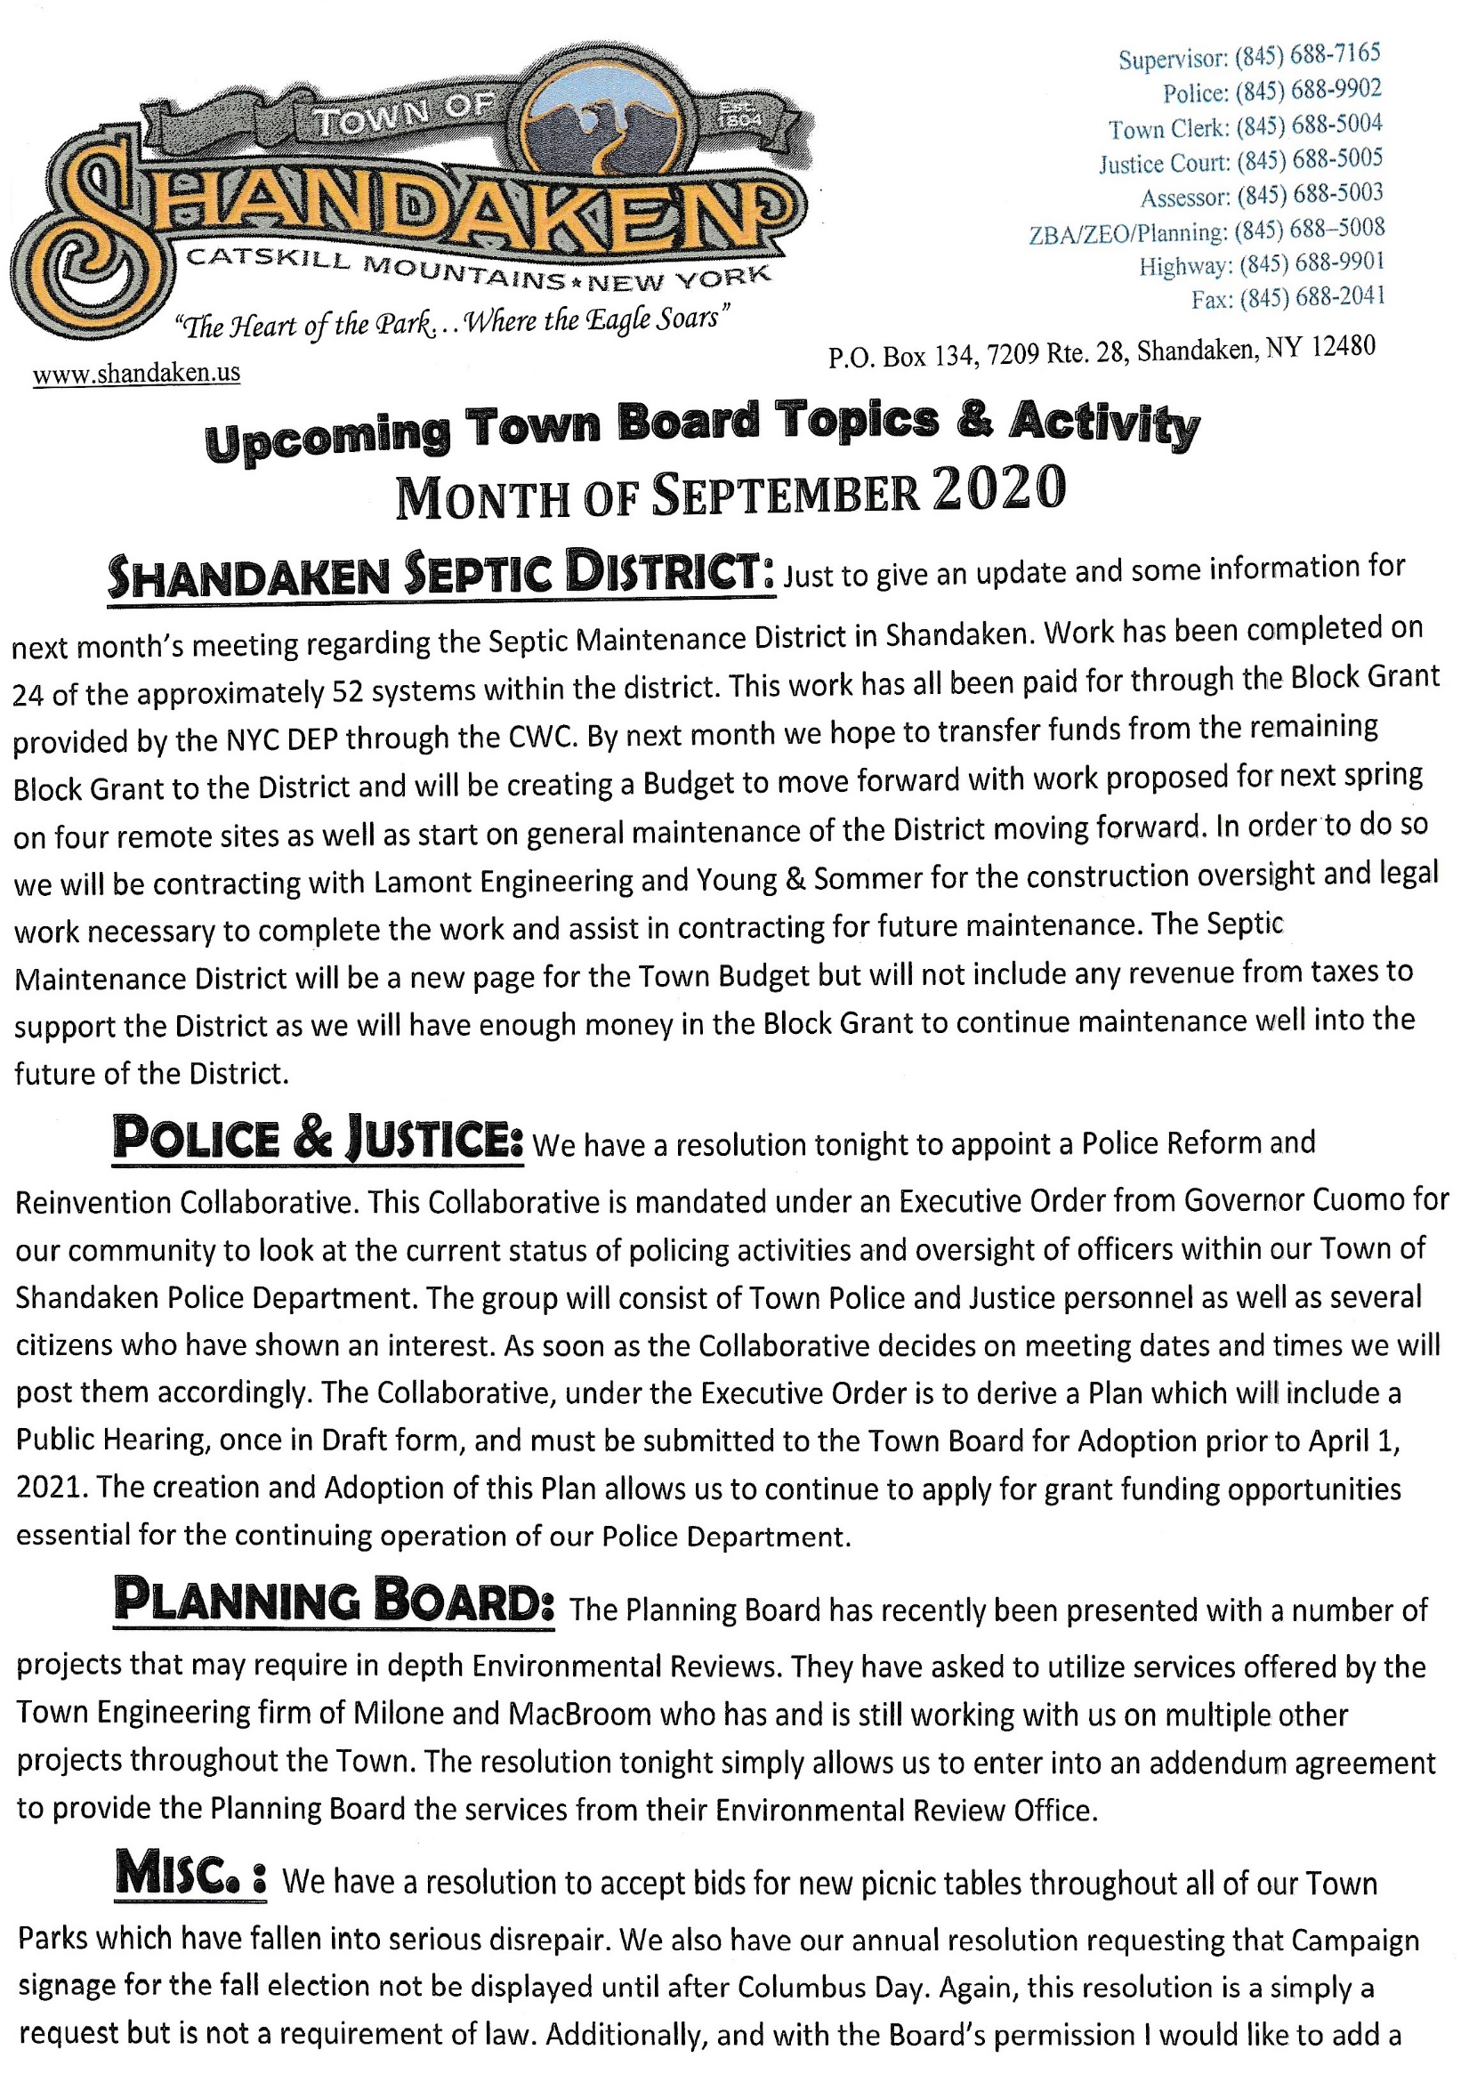

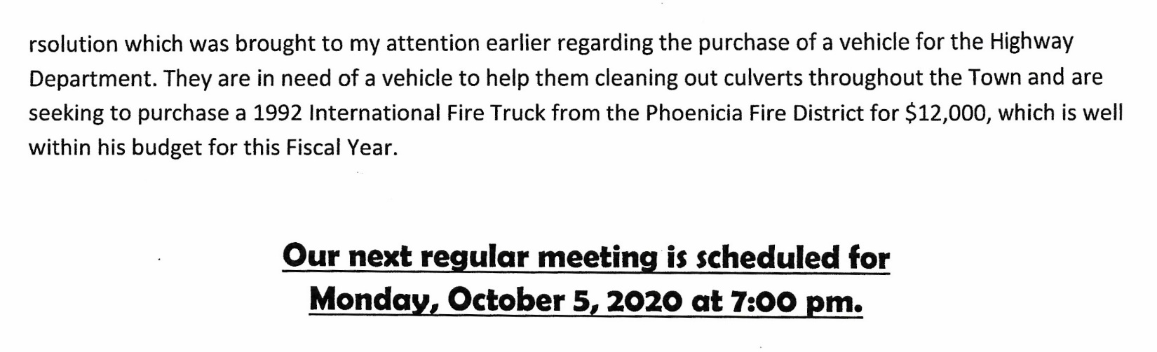
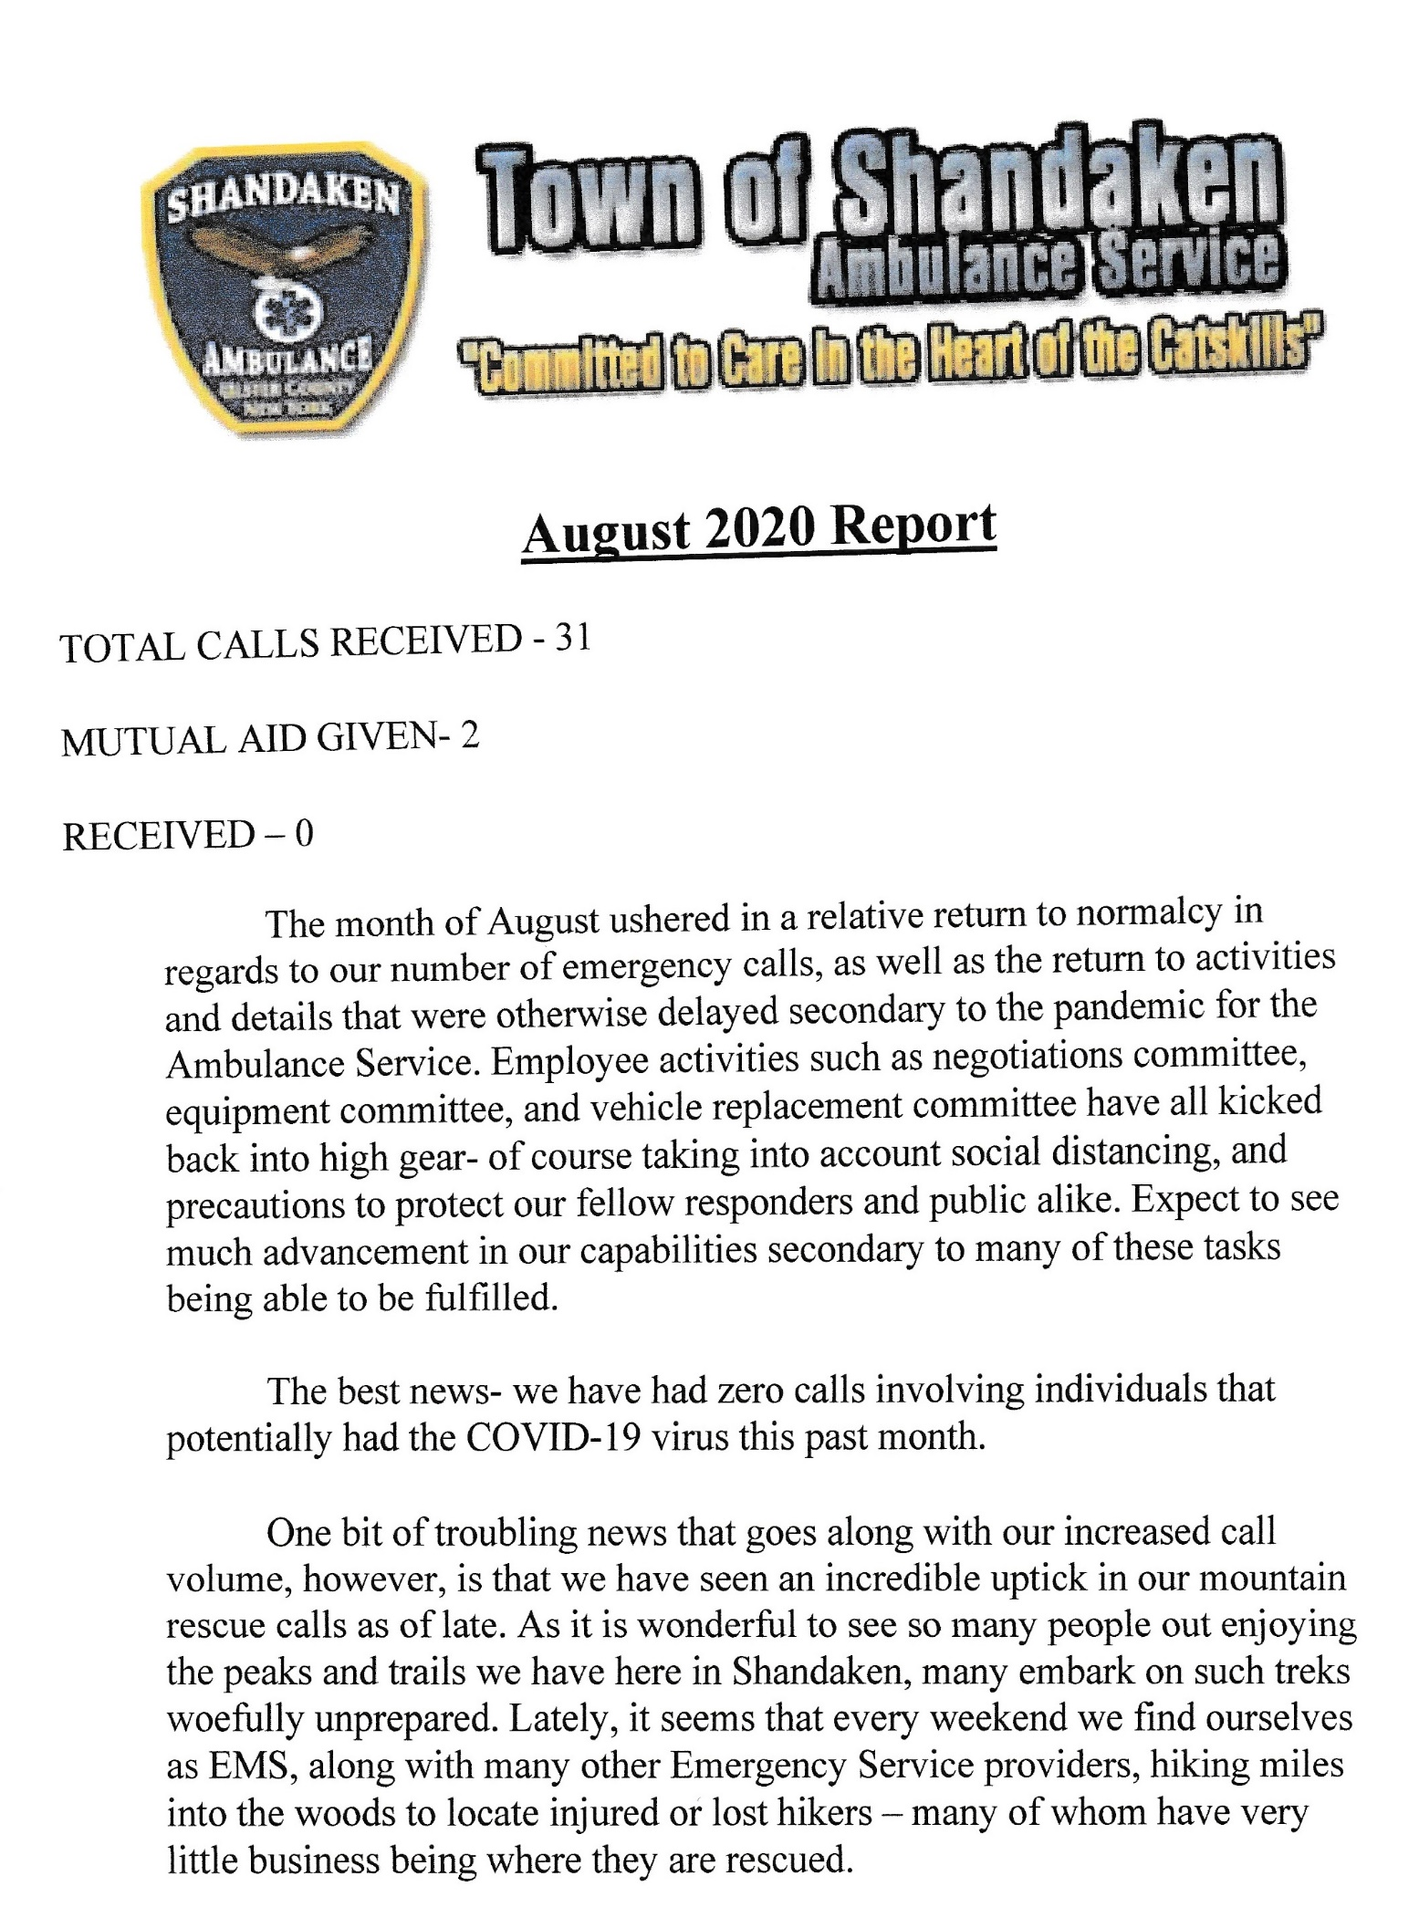
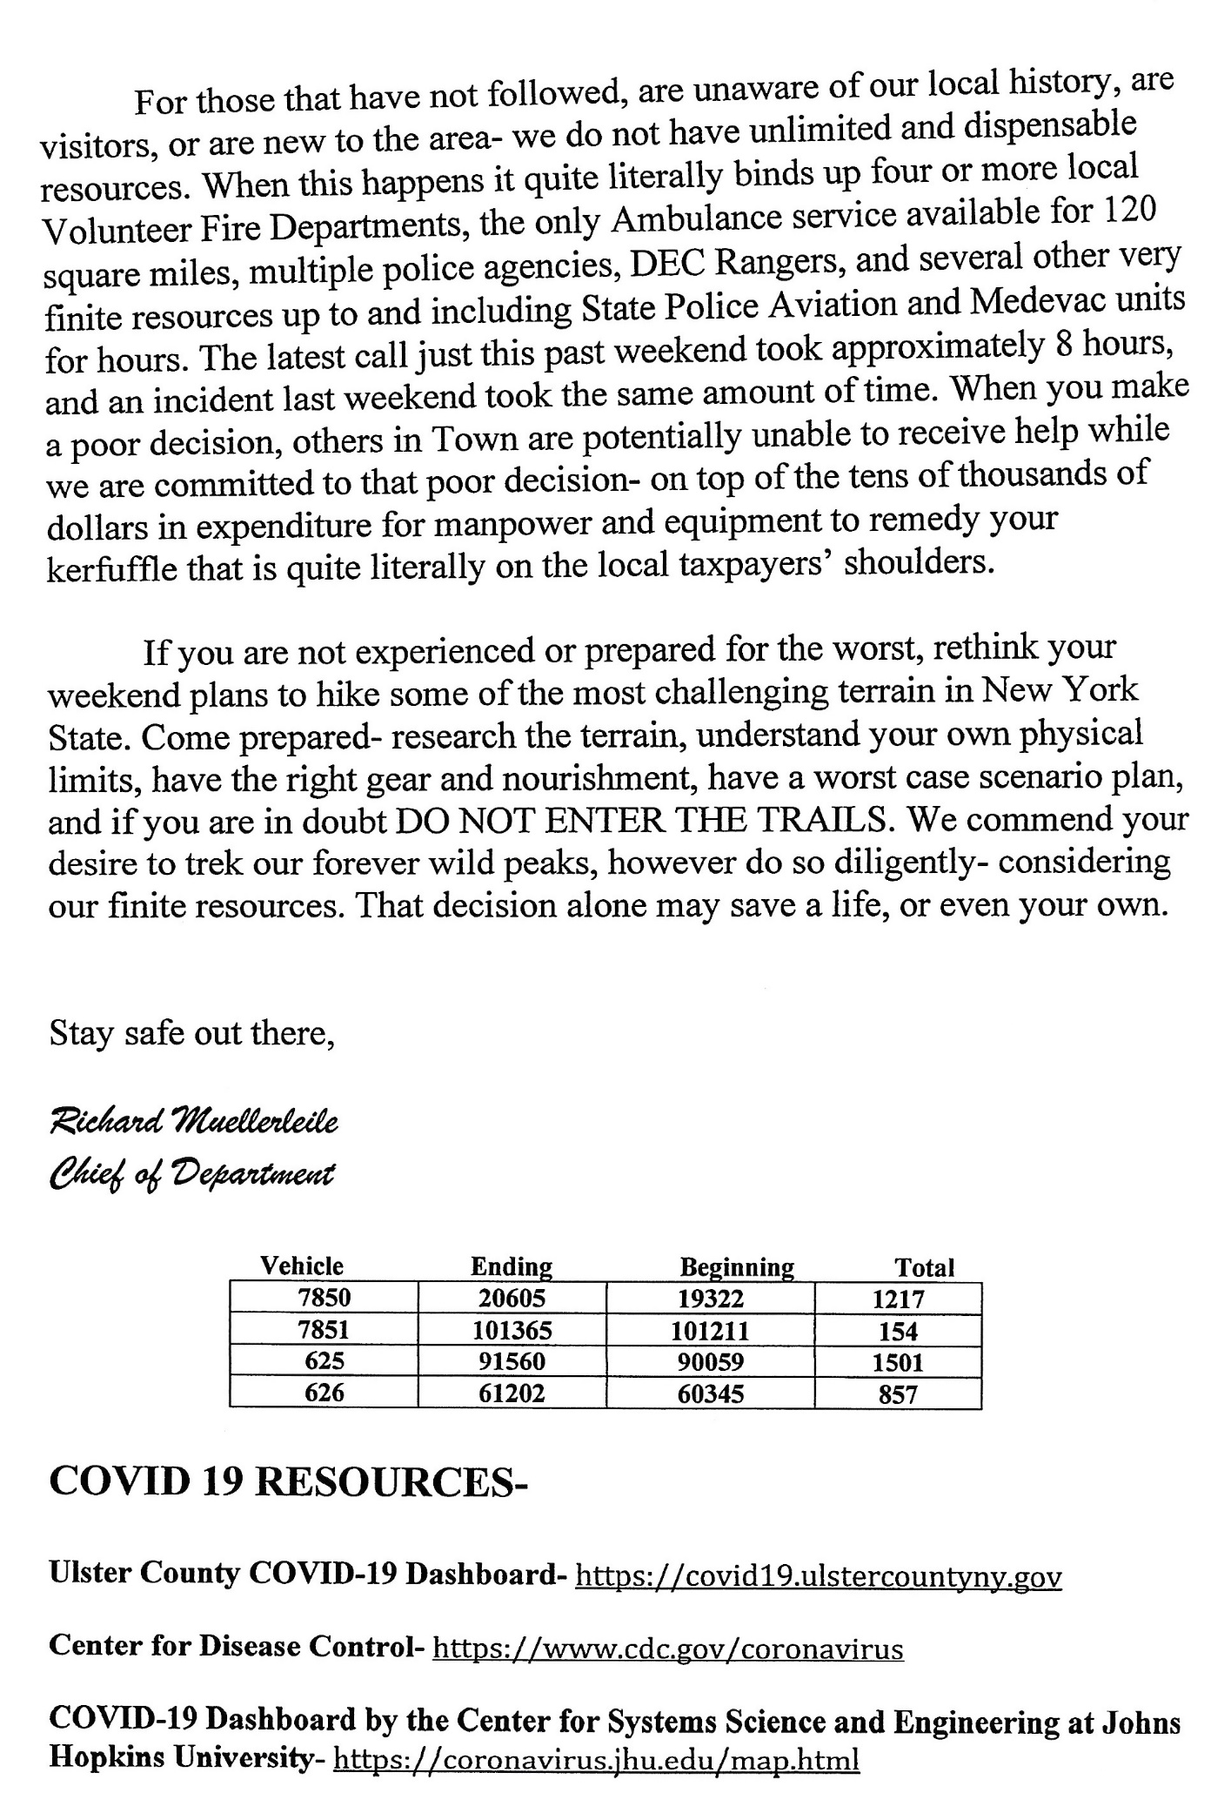
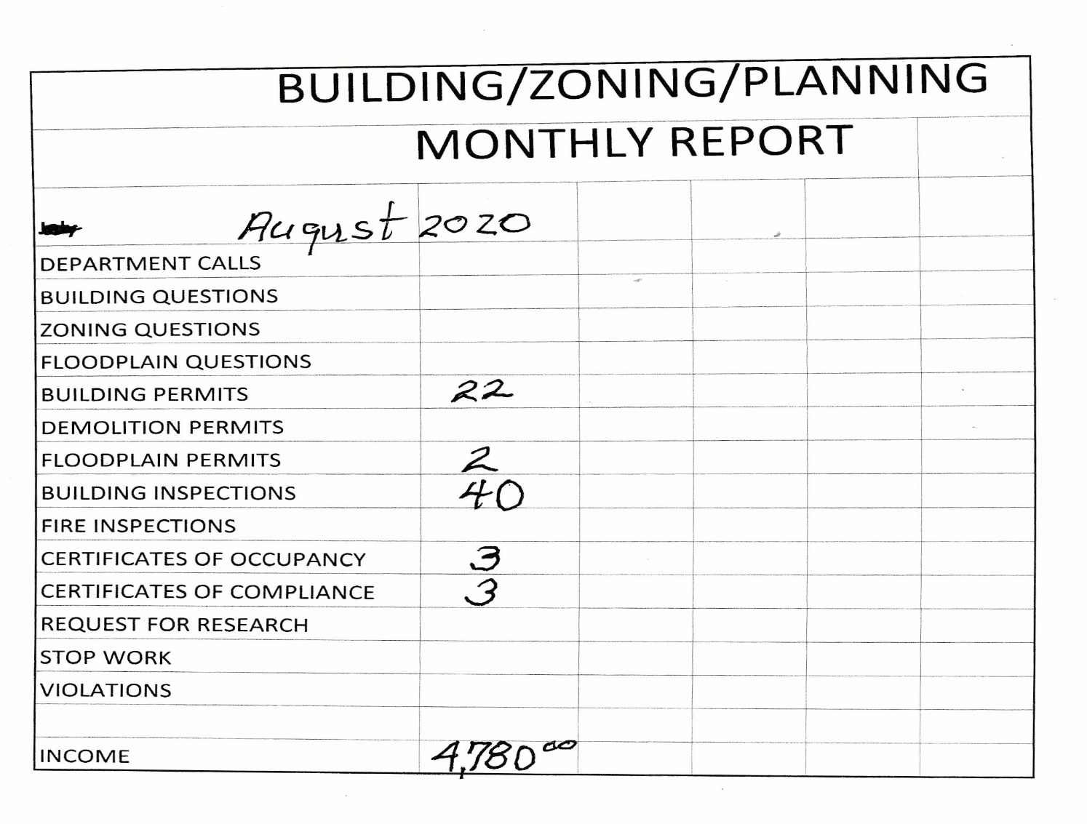
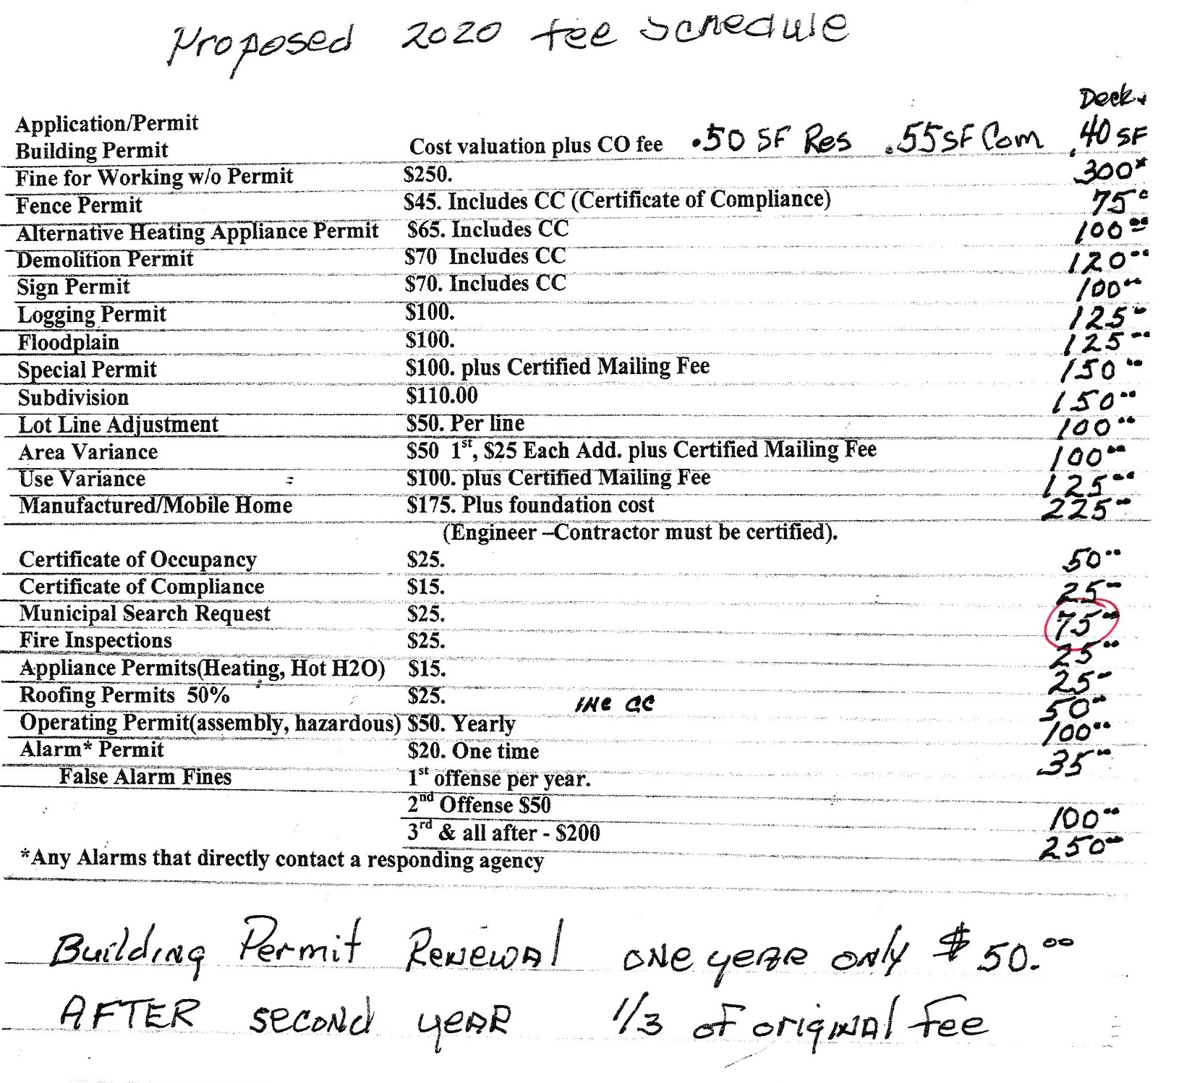

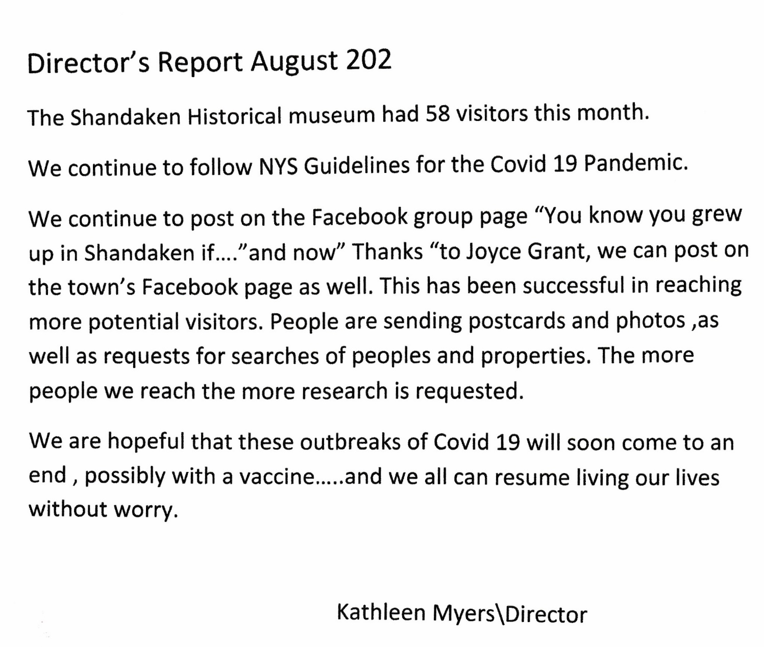

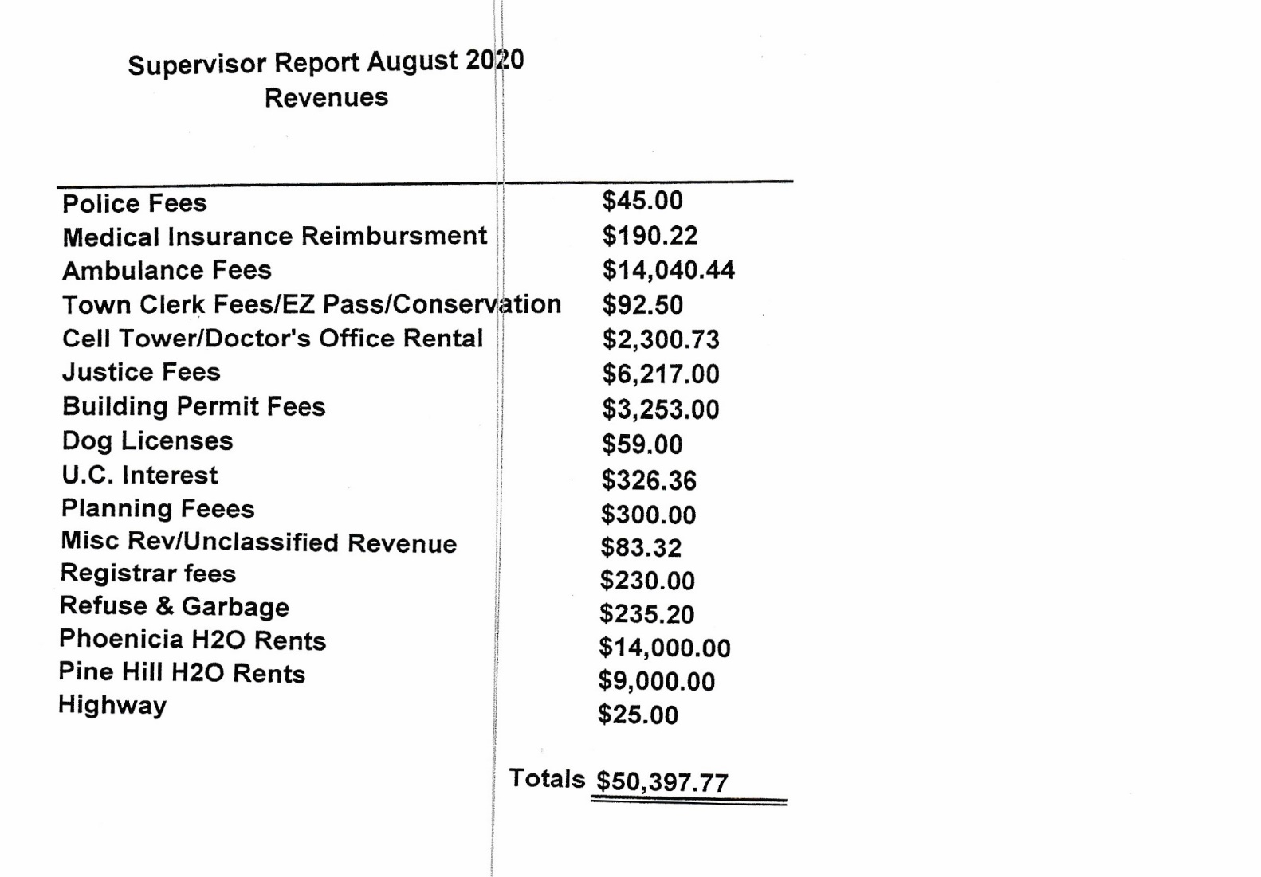
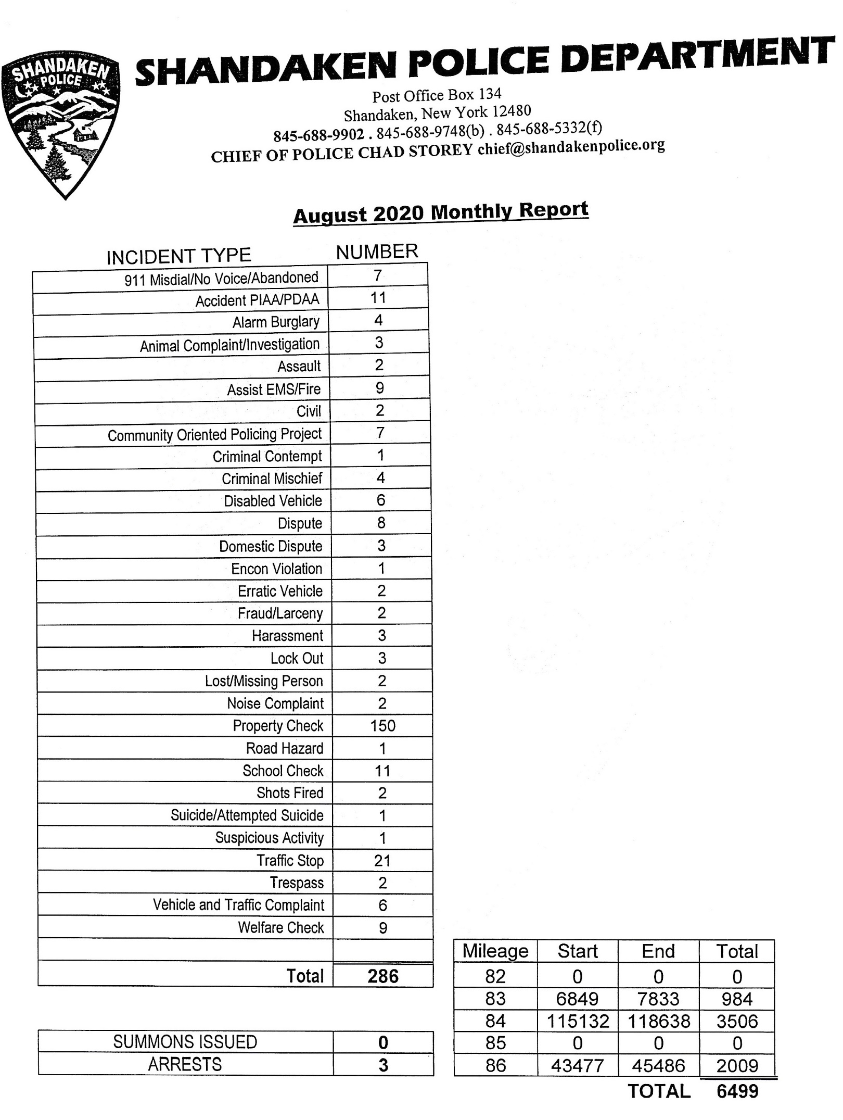
TOWN CLERK:
There has been no word yet, from Ulster Co, when the DMV bus will return to schedule.
This Sat. Sept. 19th, Outdoor Yard Sale at Phoenicia Fish & Game.
Mobile Vet Van will be at Shandaken Town Hall on Sat, Oct. 10th. Shots at 9am, surgeries throughout the day. $25 Cat Spay/Neuter program through Town Clerk Office.

Vivian Welton – Spoke about the 2020 Census – Online at https://2020census.gov/

MOTIONS: After all COVID-19 precautions were reviewed and discussed, On a Disclafani/Vanblarcum motion the Town Board unanimously agreed to let Mountain Valley Little League use Glenbrook Park for their short, Fall season.

At 8:11 pm the Town Board, on a Disclafani/Storms motion, closed the Regular Meeting to go to Executive Session.
A clarification on a Personnel, Payroll issue was resolved.
The Town Bd closed the Executive Session at 8:20 & re-convened the Regular Meeting.
At 8:22 on the Vanblarcum/Disclafani motion the Town Board adjourned.

RESOLUTION #81-20 OFFERED BY: STORMS

RESOLUTION TO PAY ALL BILLS

WHEREAS, The Department of Audit and Control require Town Boards to sign and inspect all vouchers coming into the town for payment, to number and total amounts from each fund.

THEREFORE BE IT RESOLVED, that the Town Board authorize the following vouchers paid:

General $ 75,455.43
Highway 169,114.82
Phoenicia Water 4,685.70
Pine Hill Water 2,426.34
Phoenicia Lights 894.67
Chichester Lights 143.64
Pine Hill Lights 520.08
------------------
$ 253,240.68

AND MOVES ITS ADOPTION

Seconded by: VANBLARCUM
ROLL CALL
AYES NAYS

BOARD MEMBER DISCLAFANI __X__ _____

BOARD MEMBER STEEN __X__ _____

BOARD MEMBER STORMS __X___ _____

BOARD MEMBER VANBLARCUM__X___ _____

SUPERVISOR STANLEY ___X__ _____

RESOLUTION #82-20 OFFERED BY: DISCLAFANI
Accept Bids – for Park Picnic Tables

WHEREAS, Pursuant to Town Board resolution, the Town of Shandaken Town Board Advertised for bids for 10 (ten), 8 (eight) foot All Weather Picnic Tables for various parks in Shandaken

WHEREAS, bids – clearly marked on envelope ‘Picnic Tables Bid’ were received at the Town Clerk’s Office, Shandaken Town Hall, 7209 Route 28, PO Box 67, Shandaken, NY 12480 no later than 3pm on Monday, September 14, 2020. All submissions would be certified by the Town Clerk as received by that time and the Town Board reserved the right to reject any or all bids.

THEREFORE, BE IT RESOLVED, that the following bids were received and accepted as qualified bidders-
AMERICAN REC. PROD. 144-1 REMINGTON BLVD RONKONKOMA NY 11779 $6,946 - $6,786 $7,199
NVB PLAYGROUNDS 3623 N. 700 WEST GREENFIELD IN 46140 - $8,361.36
PILOT ROCK – RJ THOMAS MFG. PO BOX 946 CHEROKEE IA 51012 - $8,893.40
ROSE MOUNTAIN WOODWORKS – PO BOX 93 SHANDAKEN NY 12480 $4,750

BE IT FURTHER RESOLVED, After review and consideration, the Town Board hereby awards the Picnic Table Bid to ROSE MOUNTAIN WOODWORKS in the amount of $4,750.

AND MOVES ITS ADOPTION

Seconded by: STEEN
ROLL CALL
AYES NAYS

BOARD MEMBER DISCLAFANI __X__ _____

BOARD MEMBER STEEN __X__ _____

BOARD MEMBER STORMS __X___ _____

BOARD MEMBER VANBLARCUM__X___ _____

SUPERVISOR STANLEY ___X__ _____

Resolution #: 83-20 Offered By: VABLARCUM

Resolution Establishing Town of Shandaken Police Reform and Reinvention Collaborative

Whereas, on August 17, 2020 the Town of Shandaken was in receipt of a letter from Honorable New York State Governor Andrew M. Cuomo regarding Executive Order 203 of 2020 requiring each local municipality in the State to adopt a policing reform plan by April 1, 2021; and
Whereas, that plan is to be developed between a Collaborative of key stakeholders involved in law enforcement and the general public from that community; and
Whereas, the development of the Police Reform and Reinvention Collaborative (PRRC) is to include public meetings and hearings on any plan to be developed; and
Whereas, the Town of Shandaken PRRC Plan must be adopted by the Town Board and a copy sent to the NYS Division of Budget no later than April 1, 2021.
Therefore, Be It Now Resolved the Town of Shandaken Town Board hereby establishes the Town of Shandaken Police Reform and Reinvention Collaborative including the following members:
Kevin Van Blarcum (Town Board), Chad Storey (Town Police Chief), W. James McGrath (Town Police Commission), Wendy Lockwood (Town Court Clerk), Crystal Wei (Mt. Tremper), Michelle Spark (Mt. Tremper), Elizabeth Potter (Phoenicia), Syed Shahzad Adil Shah (Phoenicia), Charles Perez (Big Indian), Joshua Brown (Pine Hill), Manuela Jean-Pierre (Pine Hill);

Be It Further Resolved, the PRRC members, following public meetings, are directed to create a Draft Plan, and following a public hearing held by the Town Board, create a Final Plan for Town Board adoption to be submitted to the Director of the NYS Division of Budget no later than April 1, 2021.

AND MOVES ITS ADOPTION

Seconded by: STEEN
ROLL CALL
AYES NAYS

BOARD MEMBER DISCLAFANI __X__ _____

BOARD MEMBER STEEN __X__ _____

BOARD MEMBER STORMS __X___ _____

BOARD MEMBER VANBLARCUM__X___ _____

SUPERVISOR STANLEY ___X__ ____

Resolution #: 84-20 Offered By: STANLEY

Resolution Hiring Firm to Assist Planning Board with SEQR Reviews

Whereas, the Town of Shandaken Planning Board currently has several applications for projects which may require detailed environmental reviews under the New York State State Environmental Quality Review Act; and
Whereas, the Planning Board has voted to utilize the services of Milone and MacBroom, Inc. with offices located at 231 Main Street, Suite 102, New Paltz, NY 12561, for the purpose of assisting them in the SEQR process for current and future applicants and their projects.
Therefore, Be It Now Resolved the Town of Shandaken Town Board hereby authorizes the Town Supervisor to enter into an addendum contract with Milone and MacBroom, Inc., to assist the Planning Board in SEQR actions.
AND MOVES ITS ADOPTION

Seconded by: VANBLARCUM
ROLL CALL
AYES NAYS

BOARD MEMBER DISCLAFANI __X__ _____

BOARD MEMBER STEEN __X__ _____

BOARD MEMBER STORMS __X___ _____

BOARD MEMBER VANBLARCUM__X___ _____

SUPERVISOR STANLEY ___X__ _____

RESOLUTION #85-20 OFFERED BY: STEEN

RESOLUTION REQUESTING NO CAMPAIGN SIGNAGE
UNTIL AFTER COLUMBUS DAY (October 12, 2020)

WHEREAS, the Town of Shandaken recognizes the importance of preserving its natural beauty and viewscapes throughout the Town and

WHEREAS, Columbus Day weekend is recognized as a highly desirable time for visitors to travel to our area and enjoy the pristine beauty of Shandaken.

THEREFORE, the Town Board of Shandaken requests that campaign signs for the General Election regardless of party affiliation or contest, not be displayed until after Columbus Day, Monday October 12, 2020.
.
AND MOVES ITS ADOPTION

AND MOVES ITS ADOPTION

Seconded by: STANLEY
ROLL CALL
AYES NAYS

BOARD MEMBER DISCLAFANI __X__ _____

BOARD MEMBER STEEN __X__ _____

BOARD MEMBER STORMS __X___ _____

BOARD MEMBER VANBLARCUM__X___ _____

SUPERVISOR STANLEY ___X__ _____

RESOLUTION #86-20 OFFERED BY STANLEY
Resolution for Purchase of Replacement Highway Equipment
Whereas, the Town of Shandaken Highway Superintendent has voiced the need for a replacement truck to clean out highway culverts. And has requested the purchase of a 1992 International Fire Truck from the Phoenicia Fire District.. Mileage is 25,365. Vin #1HTSDPBR2NH397143.
THEREFORE, BE IT RESOLVED, The Town Board hereby approve the purchase of the aforementioned fire truck from the Phoenicia Fire District, for the cost of $12,000.
AND MOVES ITS ADOPTION

Seconded by: DISCLAFANI
ROLL CALL
AYES NAYS

BOARD MEMBER DISCLAFANI __X__ _____

BOARD MEMBER STEEN __X__ _____

BOARD MEMBER STORMS __X___ _____

BOARD MEMBER VANBLARCUM__X___ _____

SUPERVISOR STANLEY ___X__ _____

At 8:22 on a Vanblarcum/Disclafani motion, the Town Board adjourned.

Signed this 15th day of September, 2020

________________________________________________
Joyce Grant, Town Clerk

